What is WEBGL?

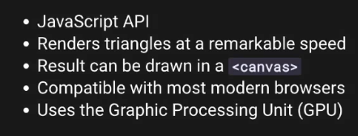

How to load THREE.JS?

We can do it several ways,

1. With script:
   1. Go to <https://threejs.org>
   2. Click on download
   3. Unzip, go to build folder and get the three.min.js
   4. Finally add the script in the html. It is important to add the three.js script first before our own JavaScript script file.
   5. Now we can get the THREE variables inside the script.
2. With Webpack:
   1. We can use webpack as well, and npm to install the dependency. But in this case, we don’t need to include the scripts/css etc in the html, webpack will do it for us.
   2. We can do npm run dev to run the server and start work.

**First Scene:**

We need 4 elements to get started.

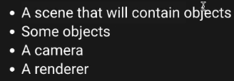

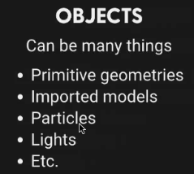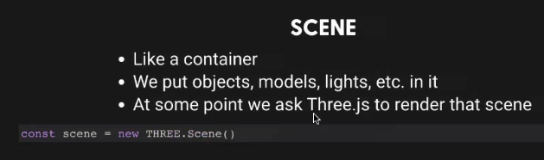

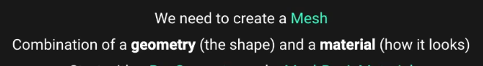

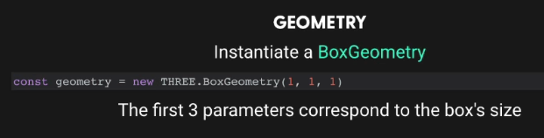

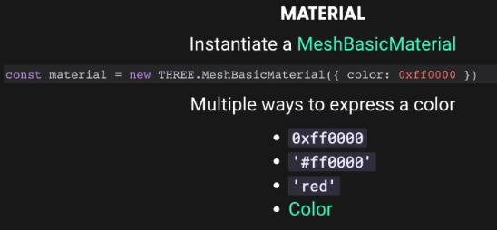

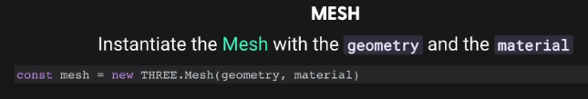

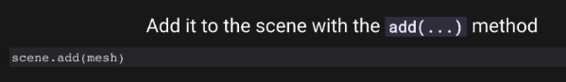

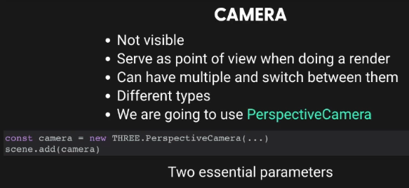

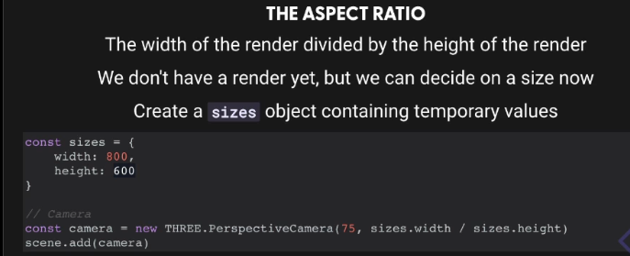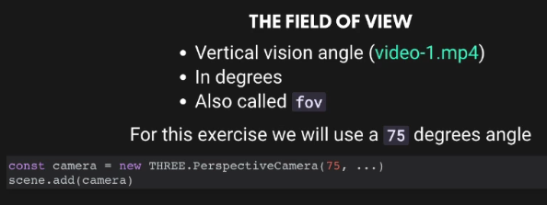

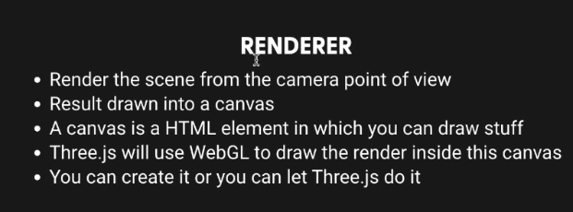

**Transforming an object:**

There are 4 properties to transform an object. Position, scale, rotation, quarternion. Any object that inherits from the Object3D class will have these properties. For example, Mesh or PerspectiveCamera.

Position has x,y,z values. Normally x should go left and right, y should go up and down, and z should go front and and backwards. Depending on the orientation of the camera/perspective this can change.

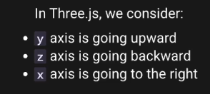

But these can be changed by us.

Scale will change the scale of each axix, it also has 3 properites x,y,z and its Vector3.

Rotation and quarternion will rotate the object, changing one will change another. It is not of type Vector3 rather its Euler. It has x,y,z properites.